PROBLEMS FOR YOU TO SOLVE

Tyler Burleson

Below, we show you the request statement and the name of the solution query in the sample databases. If you want some practice, you can work out the SQL you need for each request.

Sales Orders Database

1. “Show me all the information on our employees.”

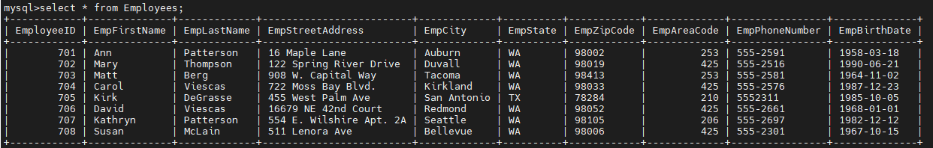

You can find the solution in CH04_Employee_Information (8 rows).

2. “Show me a list of cities, in alphabetical order, where our vendors are located, and include the names of the vendors we work with in each city.”

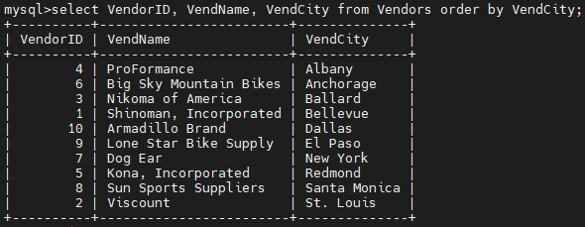

You can find the solution in CH04_Vendor_Locations (10 rows).

Entertainment Agency Database

1. “Give me the names and phone numbers of all our agents, and list them in last name/first name order.”

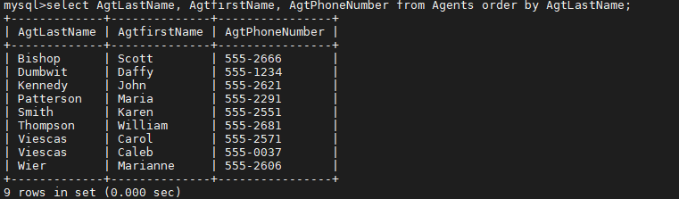

You can find the solution in CH04_Agent_Phone_List (9 rows).

2. “Give me the information on all our engagements.”

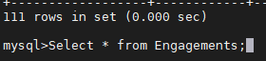

You can find the solution in CH04_Engagement_Information (111 rows).

3. “List all engagements and their associated start dates. Sort the records by date in descending order and by engagement in ascending order.”

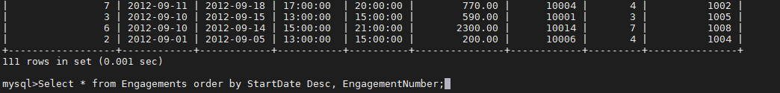

You can find the solution in CH04_Scheduled_Engagements (111 rows).

School Scheduling Database

1. “Show me a complete list of all the subjects we offer.”

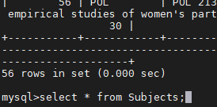

You can find the solution in CH04_Subject_List (56 rows).

2. “What kinds of titles are associated with our faculty?”

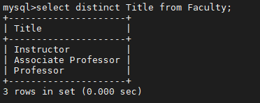

You can find the solution in CH04_Faculty_Titles (3 rows).

3. “List the names and phone numbers of all our staff, and sort them by last name and first name.”

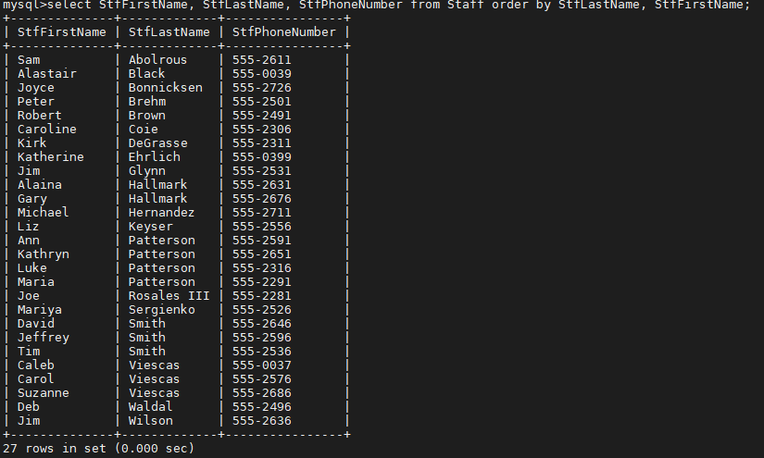

You can find the solution in CH04_Staff_Phone_List (27 rows).

Bowling League Database

1. “List all of the teams in alphabetical order.”

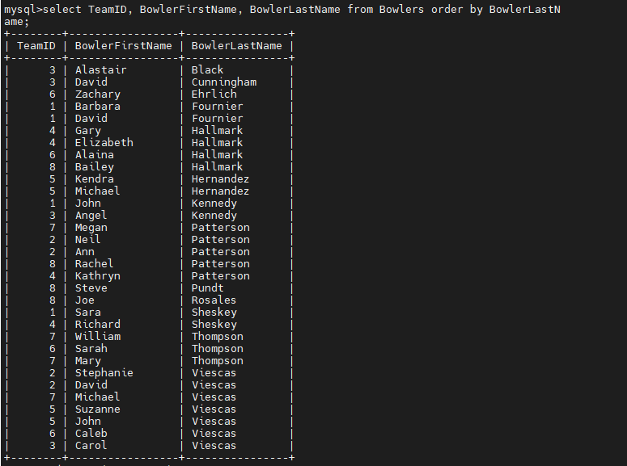

You can find the solution in CH04_Team_List (10 rows).

2. “Show me all the bowling score information for each of our members.”



You can find the solution in CH04_Bowling_Score_Information (1,344 rows).

3. “Show me a list of bowlers and their addresses, and sort it in alphabetical order.”

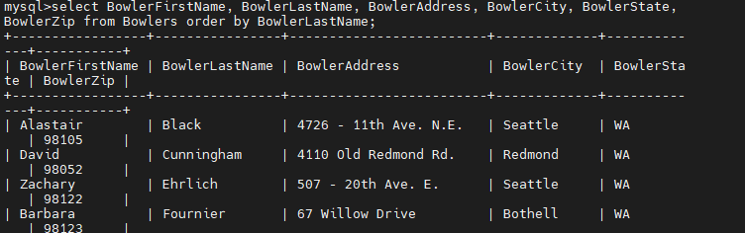

You can find the solution in CH04_Bowler_Names_Addresses (32 rows).

Recipes Database

1. “Show me a list of all the ingredients we currently keep track of.”

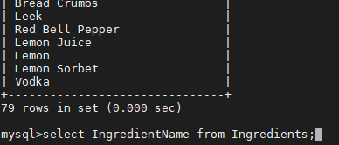

You can find the solution in CH04_Complete_Ingredients_List (79 rows).

2. “Show me all the main recipe information, and sort it by the name of the recipe in alphabetical order.”

You can find the solution in CH04_Main_Recipe_Information (15 rows).